**Step 1: Check DW Admin Log Entry Status**

Task: Run the query *SELECT * FROM dw.admin.log*

Action: Ensure that the entry status is "started" for today's date.

**Step 2: Verify NDM File Arrival**

Task: Check if all NDM files have arrived at a specific location. If files are not at the designated location, Contact Broadridge team to resend the files.

Action: Verify the NDM files at the designated location.\\sql-clst-bpsa\data\impac\download\

**Step 3:**Task: Initiate the job (COPY_LOCAL_TO_NDM) on DW1 for file transfer.

Action: Start copying the NDM files to the desired destination.

**Step 4: Confirm File Copy Completion**

Task: Ensure that all NDM files are successfully copied to the destination.

Action: Check if the NDM files are present at the location: \\10.224.15.97\nybr\FS_IC_BR\IMPACT\ICBCPROD

**Step 5: NDM Files Loading from Stored Procedure (Runs Sequentially)**

Task: Start loading the received NDM files by running the job (load_NDM_files_to_staging).

Action: Initiate the job that loads entries into category load status after NDM messages (not loaded by package) are loaded into inbound table.

**Step 6: NDM Files Loading from Package (Runs Concurrently)**

Task: Run jobs (Load_NDM_BECDLDEP, Load_NDM_CUSDLDEP, Load_NDM_EX2FILEP ,Load_NDM_FINDLDEP, Load_NDM_KKSDLDEP, Load_NDM_T9PDLDEP, Load_NDM_XGLDLDEP, Load_NDM_XPDLDEP, Load_NDM_YAPDLDEP) to load files from package. Make sure the files are in the archive folder

Action:Initiate the job that runs the package to load the files.   
\\10.224.15.97\nybr\FS_IC_BR\IMPACT\ICBCPROD\archive

**Step 7: Start Recursive Jobs on DW2**

Task: Make sure the jobs (Recursive IREP EOD & Recursive BPSA EOD) are running automatically from the scheduler.

Action: Initiate the (Recursive IREP EOD) and (Recursive BPSA EOD) on DW2 if not already initiated.

**Step 8: Check IREP MQ Load Status Report**

Task: Monitor IREP MQ load status report for any error messages.

Action: Review the IREP MQ load status report and check for error messages.If we have a Error Message Run Below query on DW-2  
*select * from dw.admin.ErrorLog*

*select * from staging.dbo.staging_lod_log_error*

*select * from staging.admin.SP_Error*  
**If we have any bigger issue while performing EOD and see errors please reach out to Bhavesh or Ravi for assistance.**

**Step 9: Verify Category Load Status**

Task: Check the category load status to ensure all files are loaded.

Action: Run this query Below

*SELECT * FROM CATEGORY_LOAD_STATUS WHERE ASOF_BUSINESS_DATE = '2024-01-01'* in the IREP_DB database.

**Step 10: Validate System Date on Both Servers**

Task: Confirm the system date on both DW1 and DW2 servers.

Action: Check the system date using the queries:

*select * from config.dbo.System_Date —* DW2 Server

*select * from Irep_DB.dbo.System_Date —* DW1 Server

**Step 11: Initiate Report Generation Job**

Task: After complete EOD and system date changed, then kick off the report generation job

Action: initiate the job (“New Report Generation") on DW2 Server

**DW Portal Check:**Process: Access the DW Portal to monitor file statuses.   
Portal Link: EOD Status Portal ([http://10.224.15.46:8080/Internal/EODStatus](http://10.1.10.5:8000/Internal/EODStatus))

Purpose: Track the progress of file processing and identify any pending or running tasks.  
  
  
**Sample of File Status after DW Portal Check:**

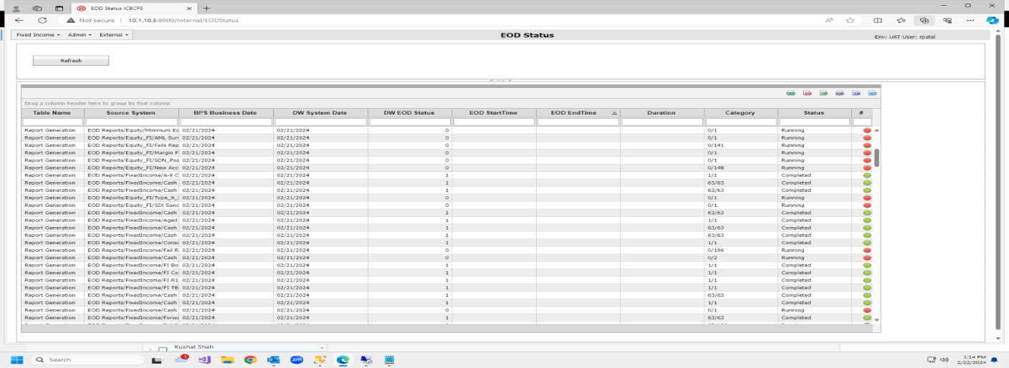

**Additional Action: If the date remains unchanged post EOD, contact Bhavesh or Ravi for assistance.**